Problem Statement:
Build an End-to-End AWS Web Application on a serverless infrastructure
Architecture:
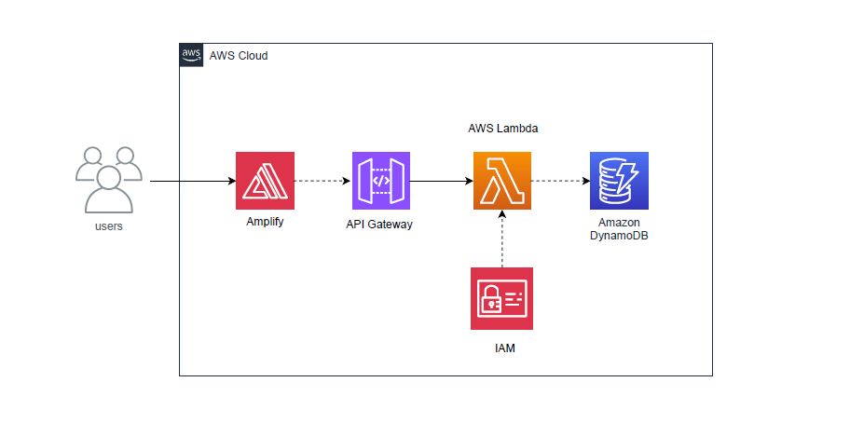
In the above architecture a webpage will be hosted on AWS Amplify. The website will connect to the API endpoint and will post the input data. AWS Lambda will process and store the data in DynamoDB. Additionally, API endpoint will return the result to the webpage. AWS Lambda will be assigned necessary policies to update in DynamoDB.
Step by Step guide:
- Create an HTML web page with the help of Notepad. Save the file as index.html
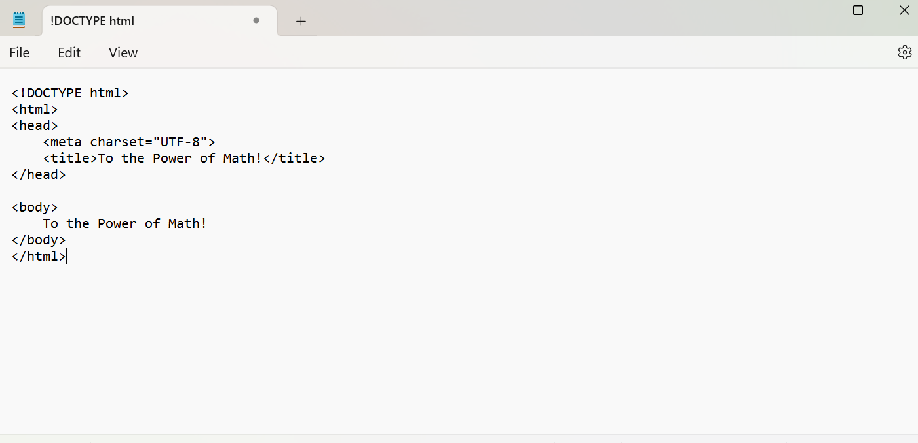
- Zip the file index.html file and then login to AWS console and open AWS Amplify
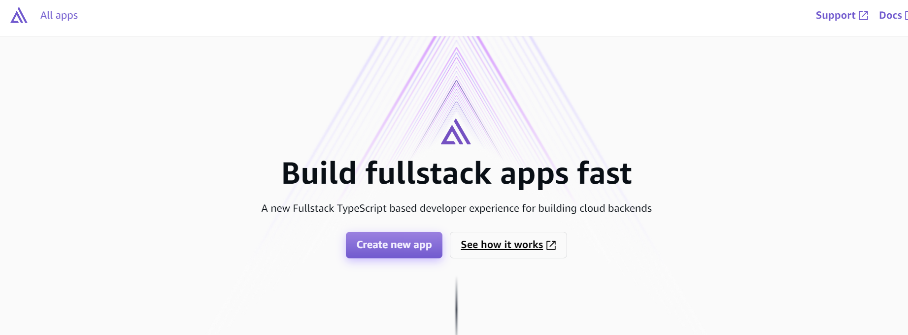
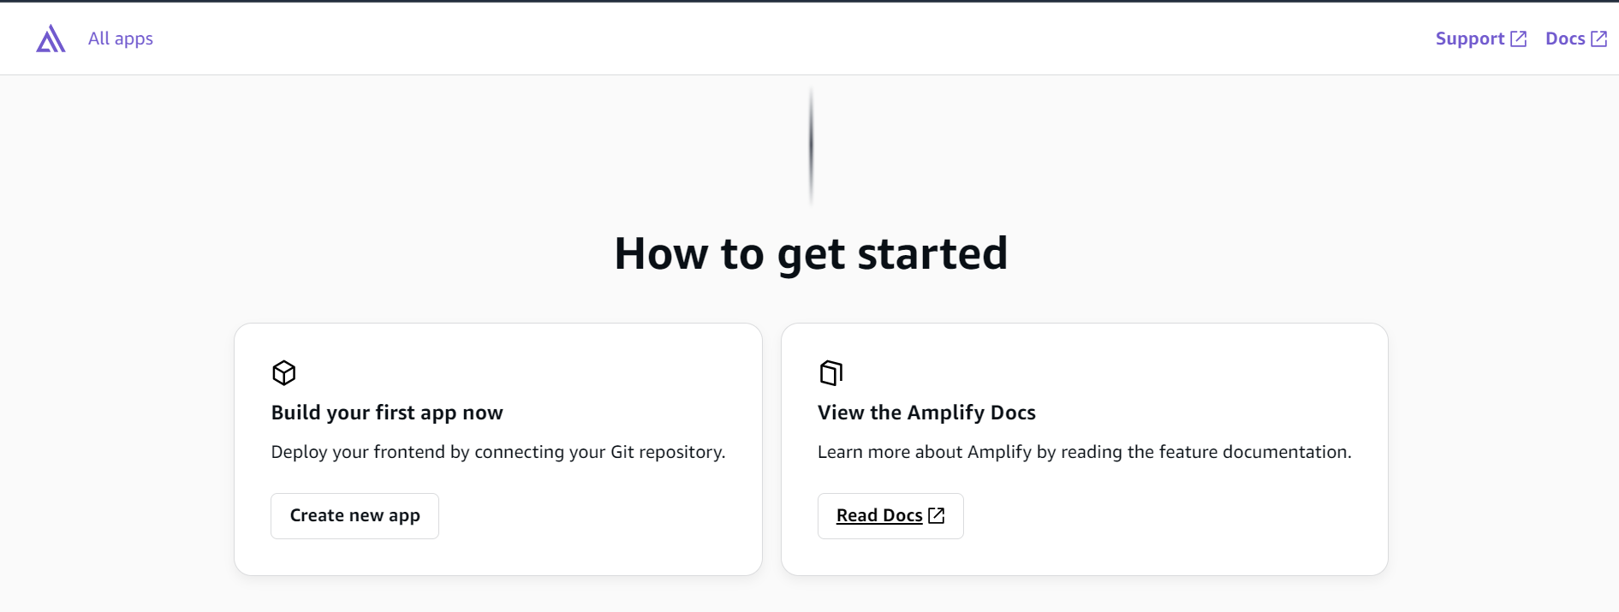
- Click create new app then open AWS Amplify. Click Deploy without Git and click Next
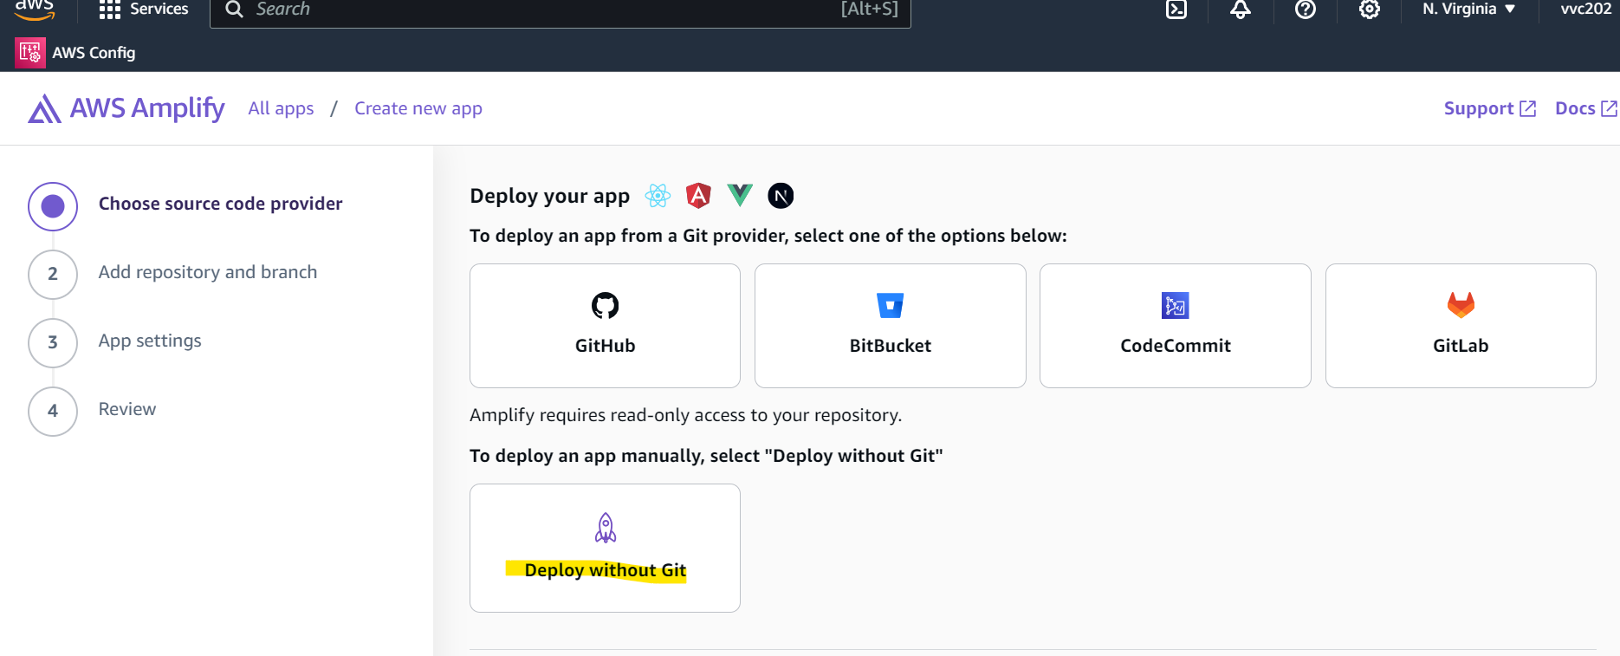
- Upload the zipped index.html by choosing the .zip folder. Click on Save and deploy
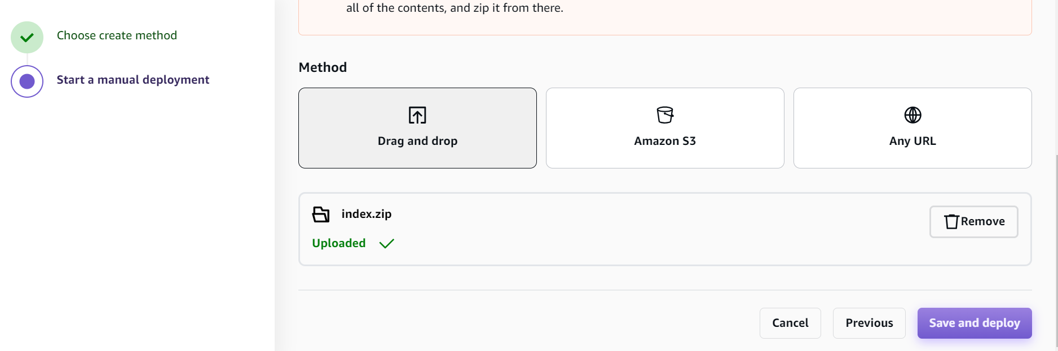
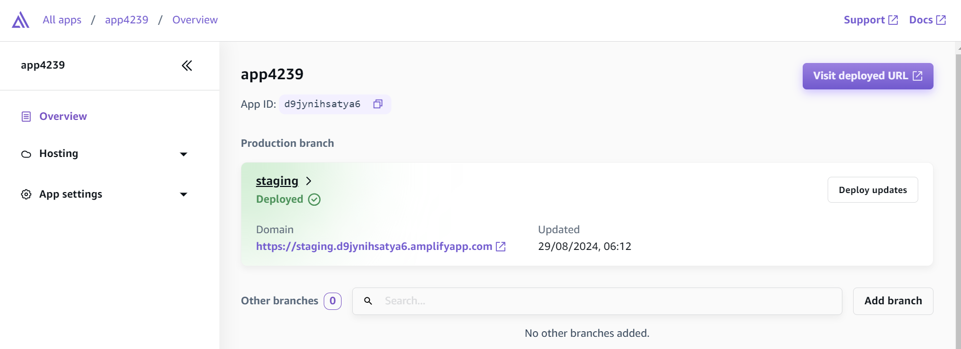

- Click on Visit deployed URL
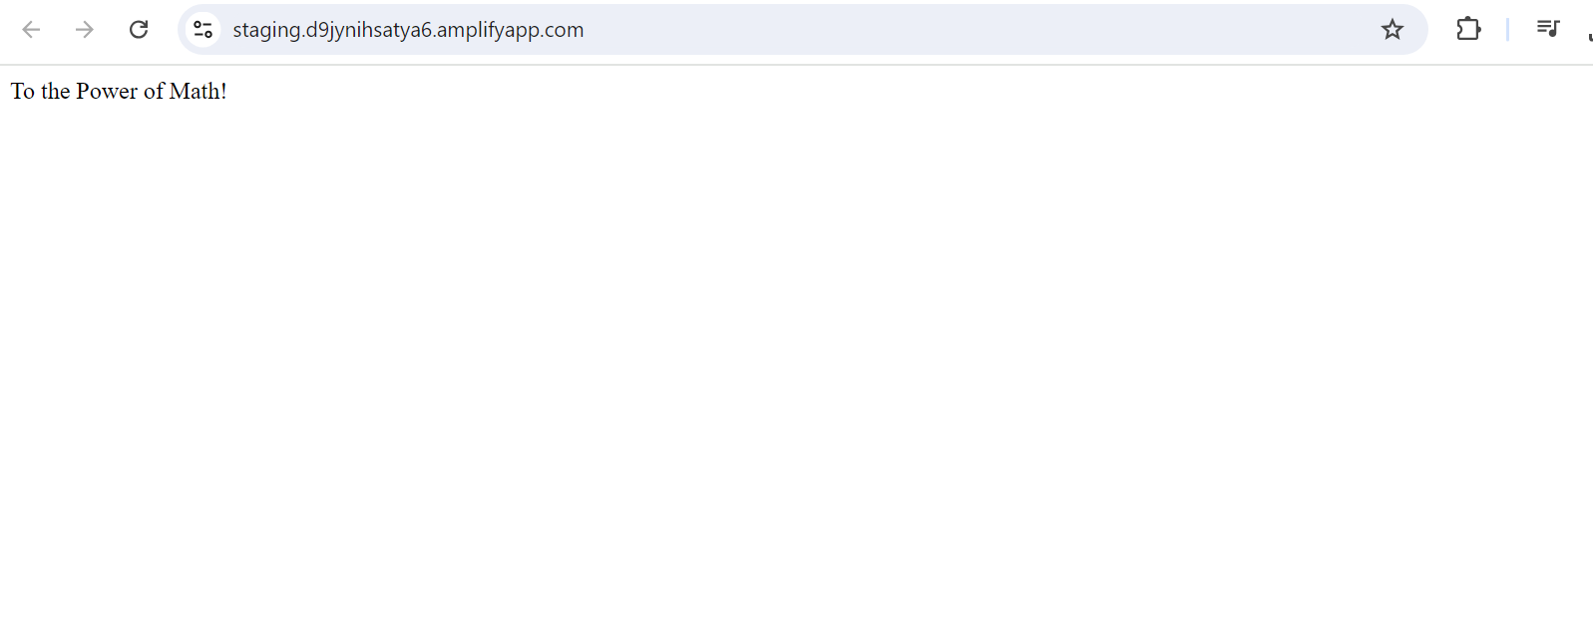
- Now to do calculation based on the input provided on the HTML page we will use Lambda function. We will use python code to achieve this. Go to AWS Lambda and click on Create function
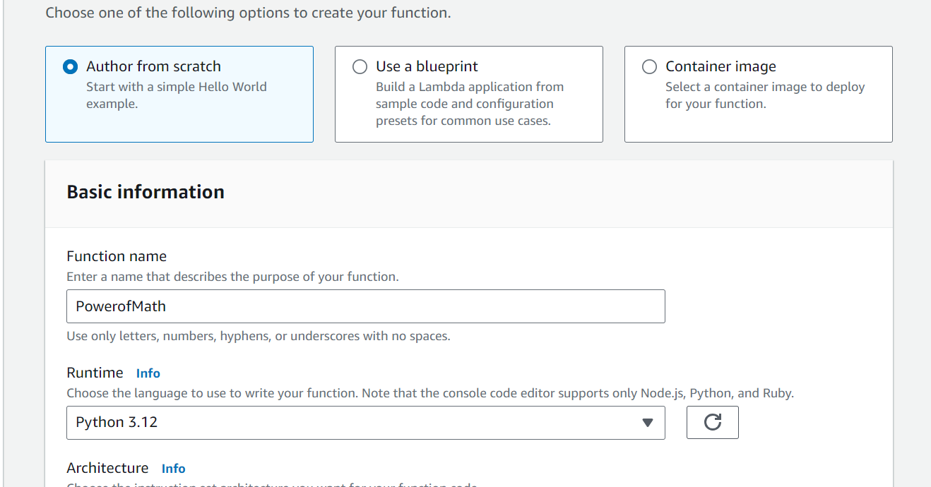

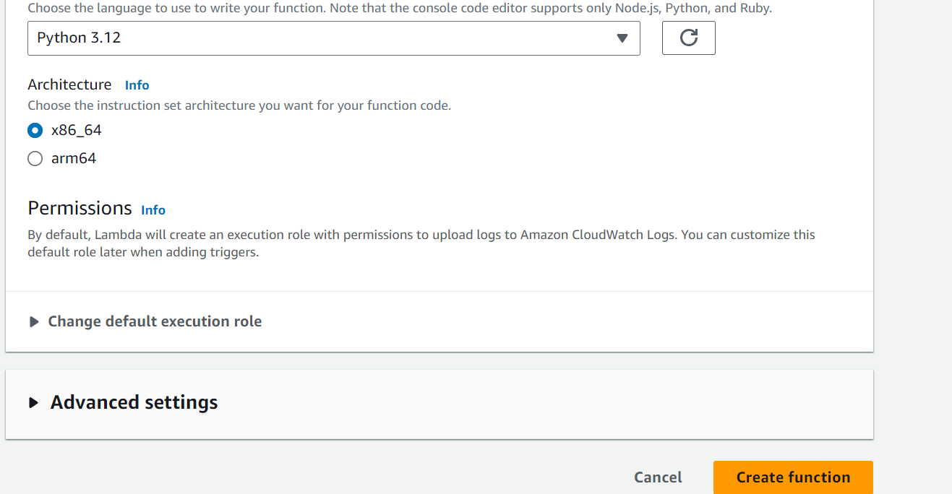
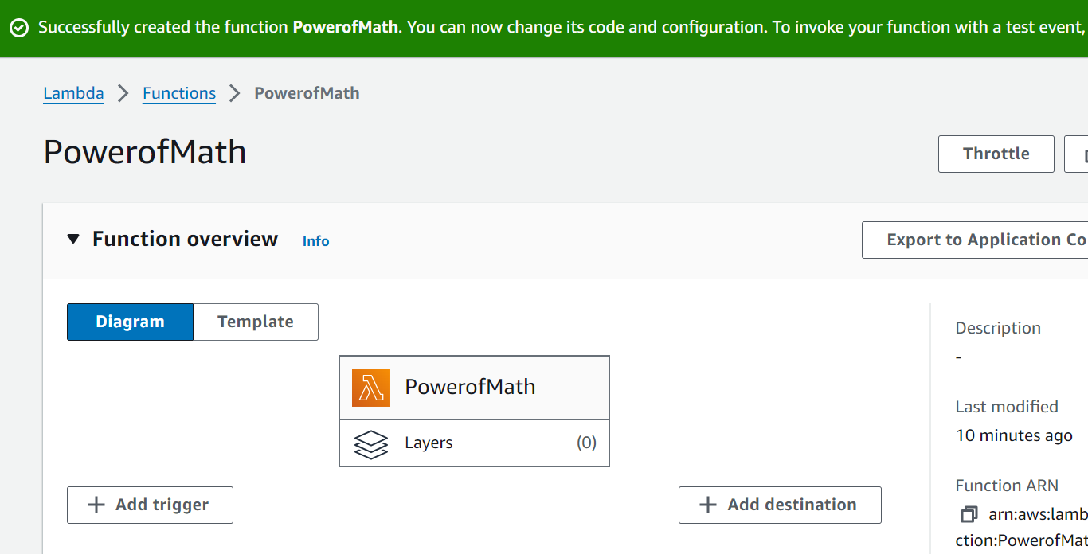

- Go to Lambda function source code and enter following code in it. It uses Python math library. Save the code within Python function using ctrl+S. Following code will be taking two inputs from the user i.e. Base and Exponent
# import the JSON utility package
import json
# import the Python math library
import math
# define the handler function that the Lambda service will use an entry point
def lambda_handler(event, context):
# extract the two numbers from the Lambda service's event object
mathResult = math.pow(int(event['base']), int(event['exponent']))
# return a properly formatted JSON object
return {
'statusCode': 200,
'body': json.dumps('Your result is ' + str(mathResult))
}
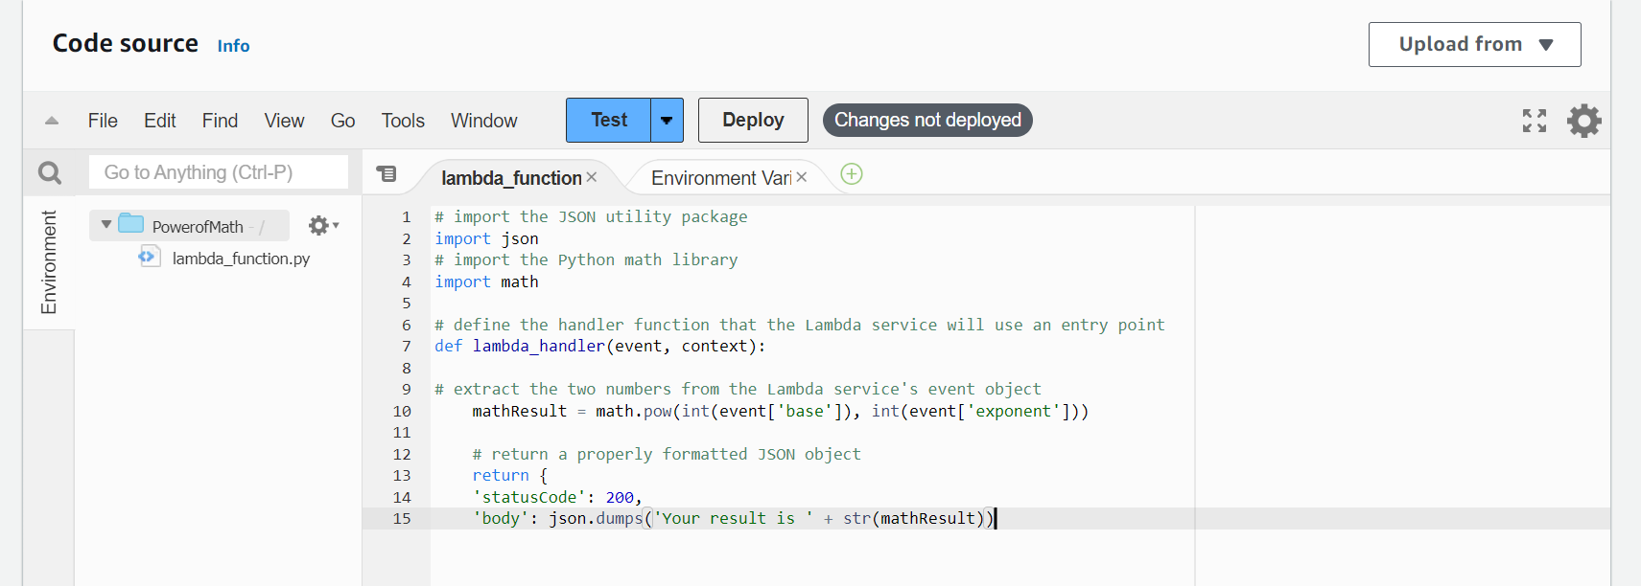

- Click on Deploy
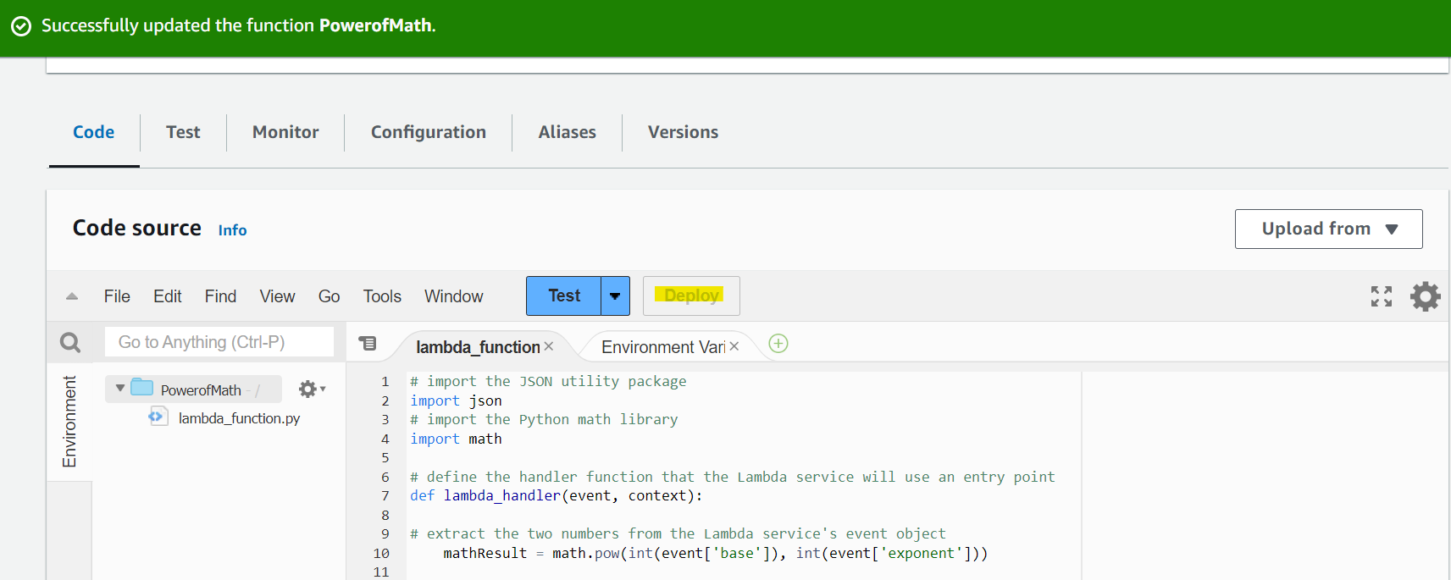

- Test the code by clicking on Test and setup test event. Since the code is expecting two values for base and exponent , enter those two values in the Event JSON and click Save
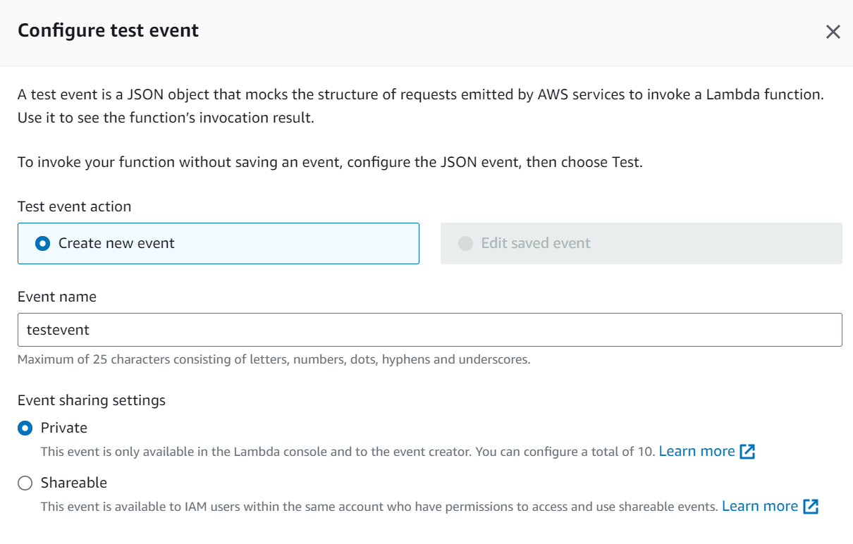
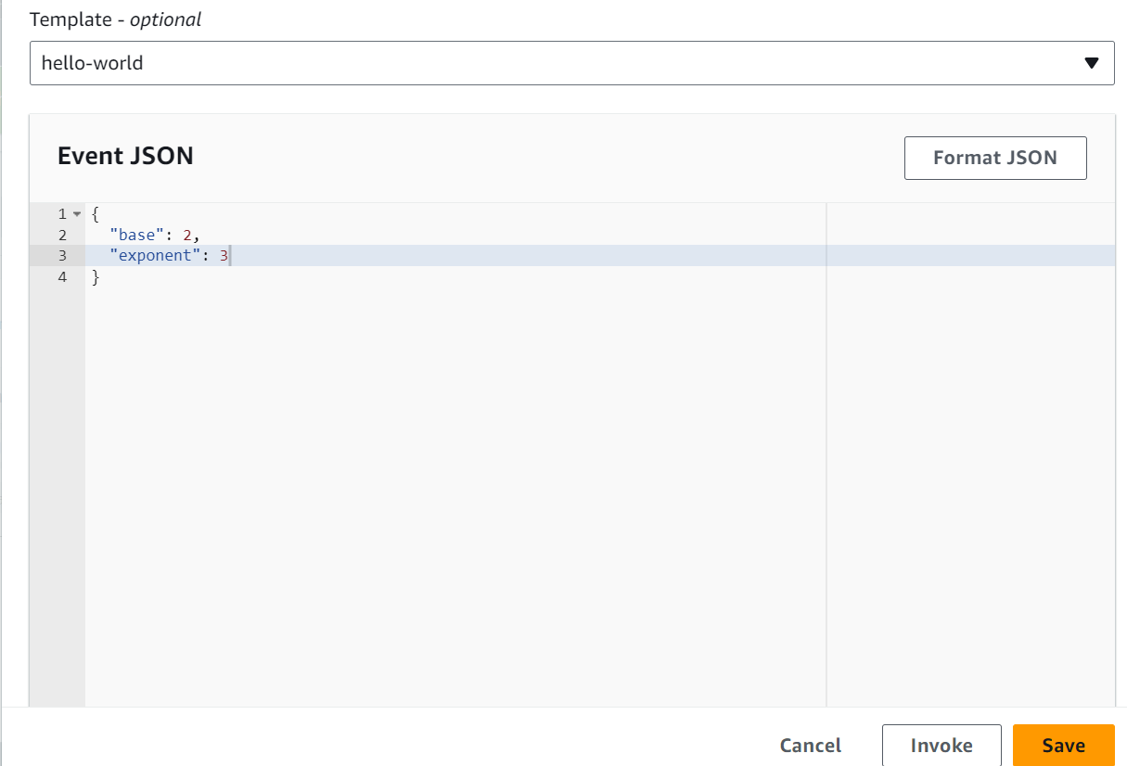
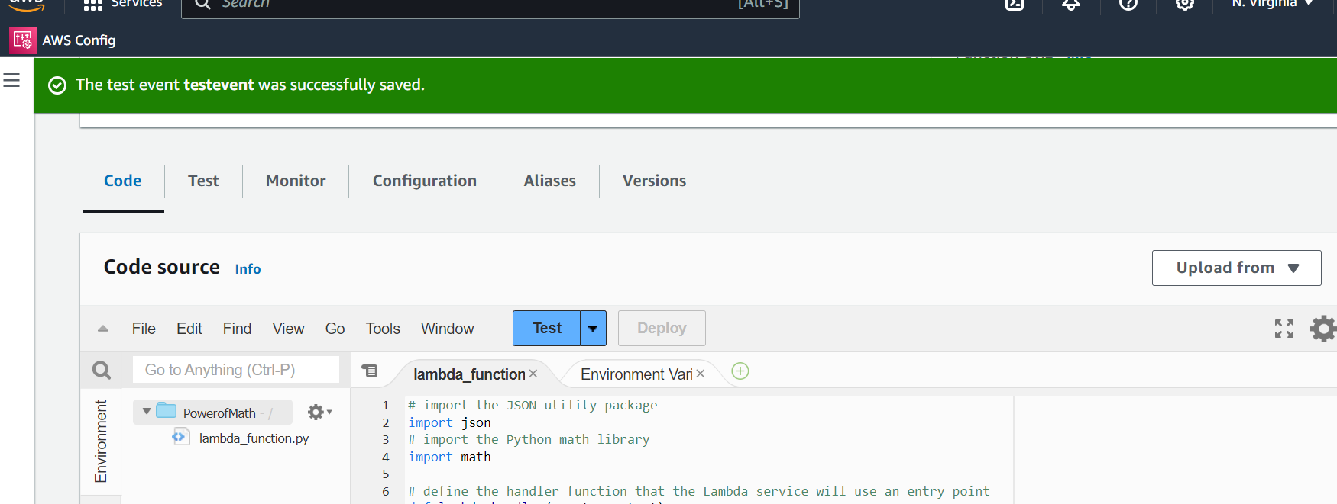

- Run the test event by clicking on Test
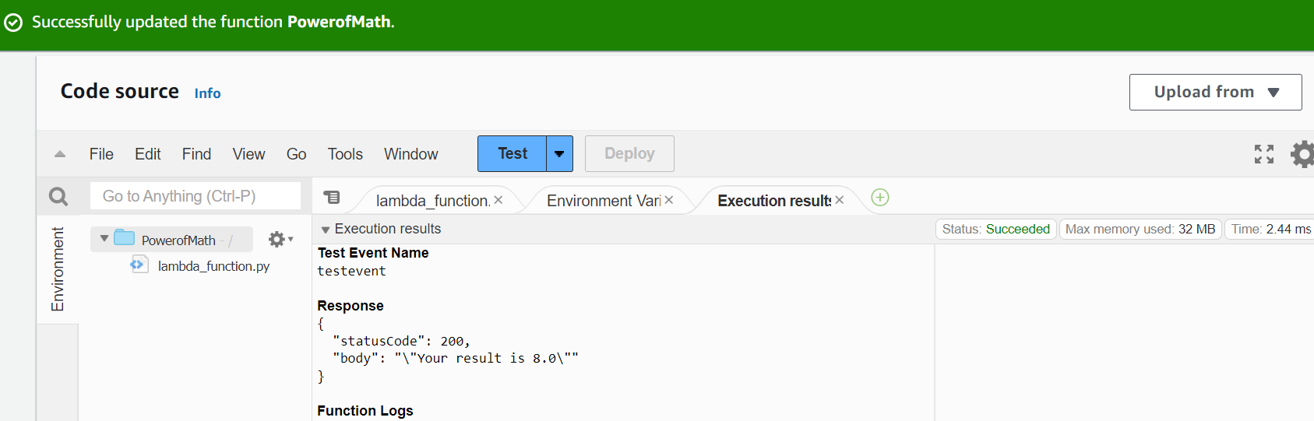
- Next step is to provide an endpoint to user to invoke that Lambda function. This can be achieved by using an API gateway. Go to API gateway. Click on Build button for Rest API
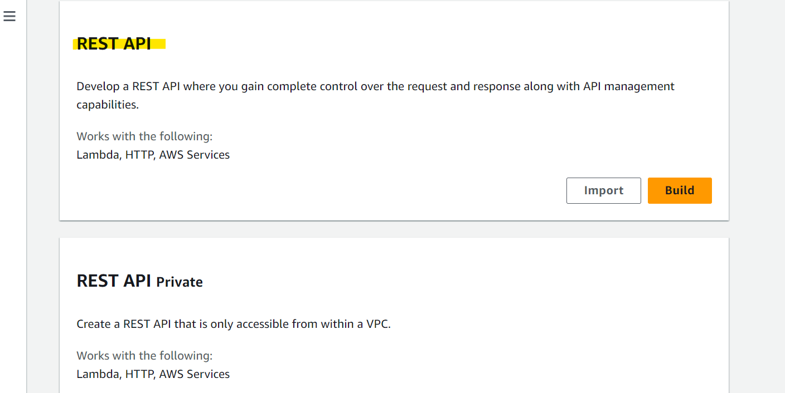
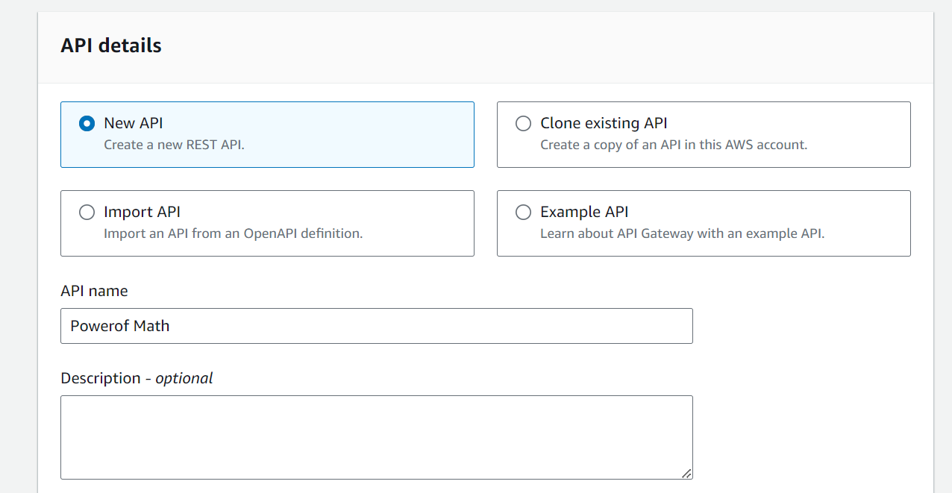
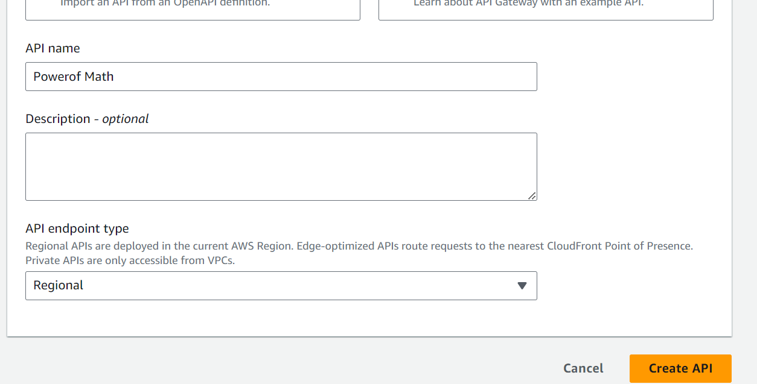
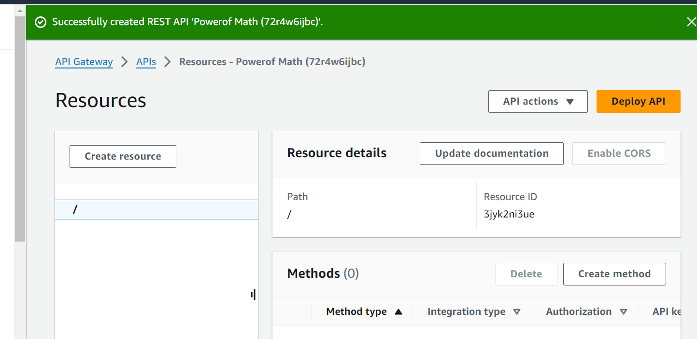

- Click on Create method and select POST since we will be passing two numbers to the Lambda function via APIs. Select Integration type and Lambda function
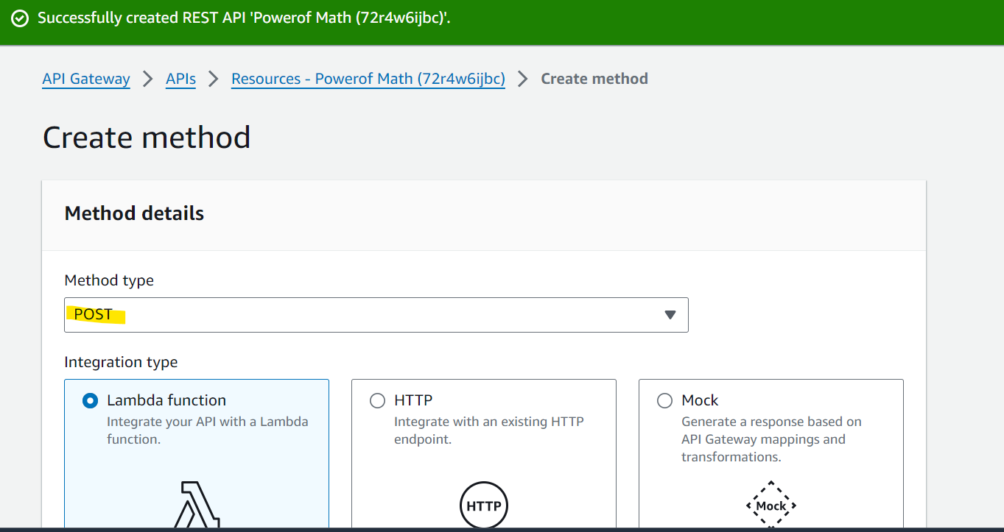
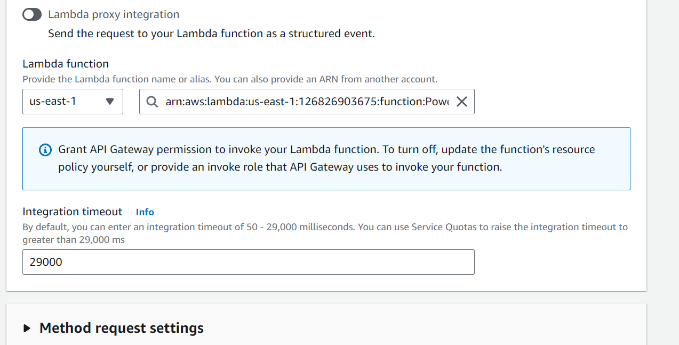
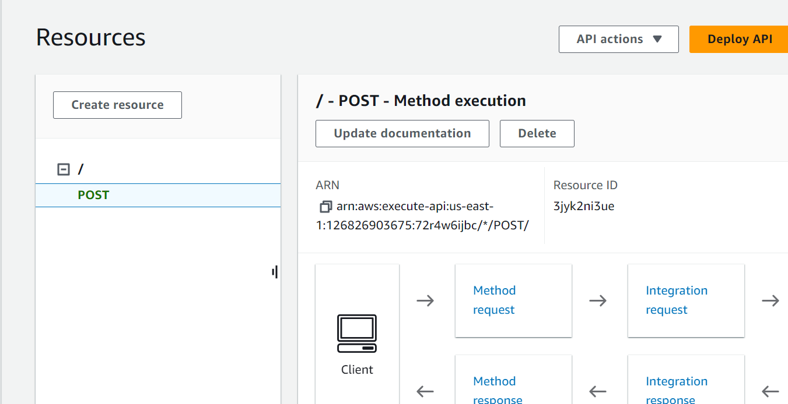

- Click on ‘/’ and go a level up. Select the POST method and click on Enable CORS. This is to ensure that the web application hosted on AWS Amplify will be able to access the code on AWS Lambda function. Select Access-Control-Allow-Methods for Post.Click on Save.
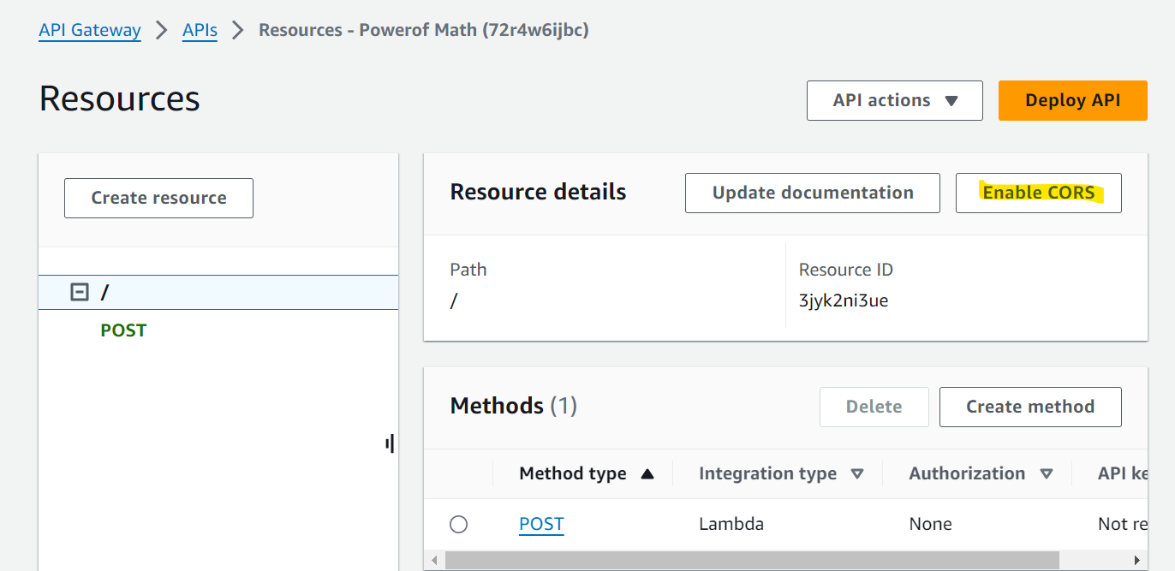
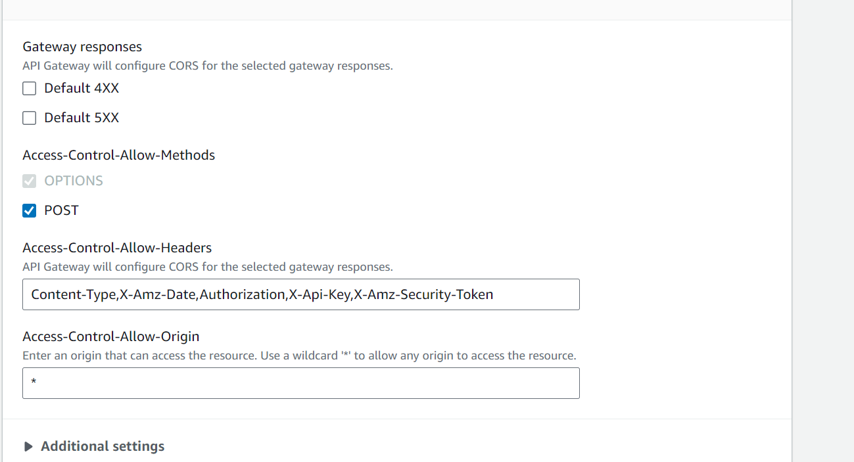

- Click on Deploy API
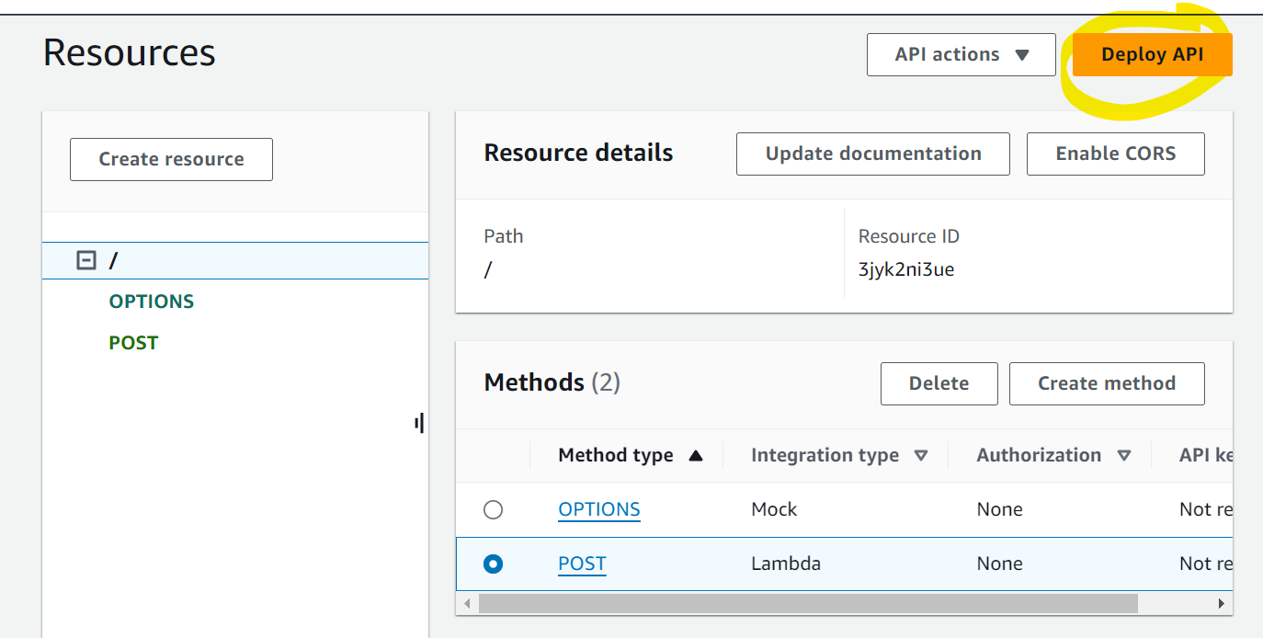

- Select ‘New Stage’ and provide the stage name as ‘dev’.
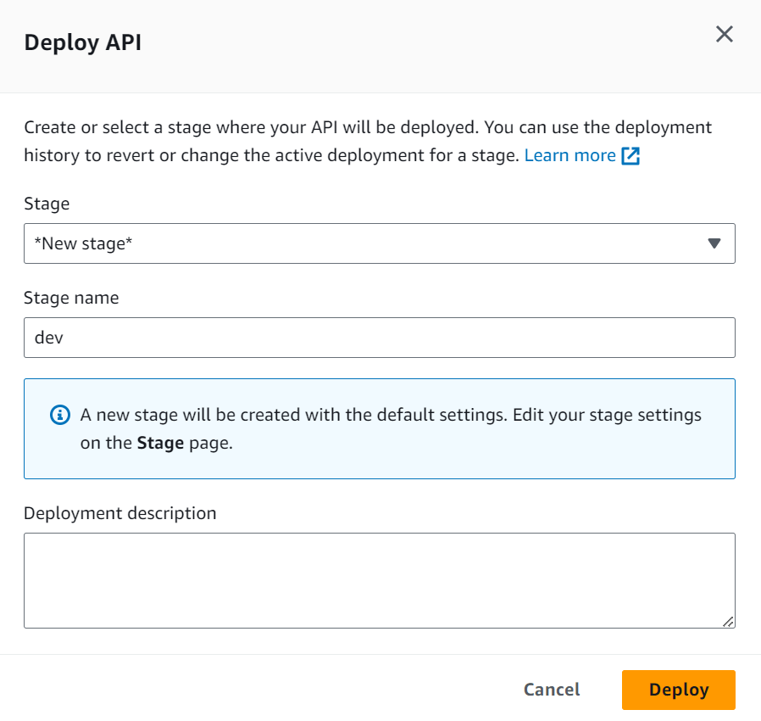

- Go to Resources and go to POST method. Select Test. Scroll down and go to the Request body. Enter values for base and exponent since Lambda will be expecting these values. The format should same as that we used to test the Lambda function. Click on Test ath the bottom of the screen
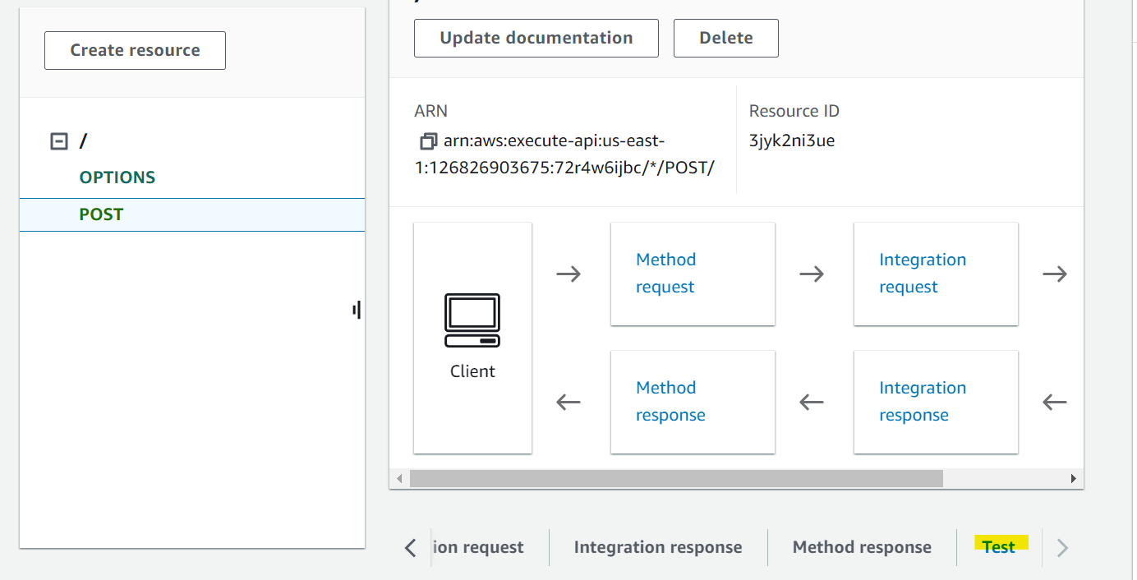
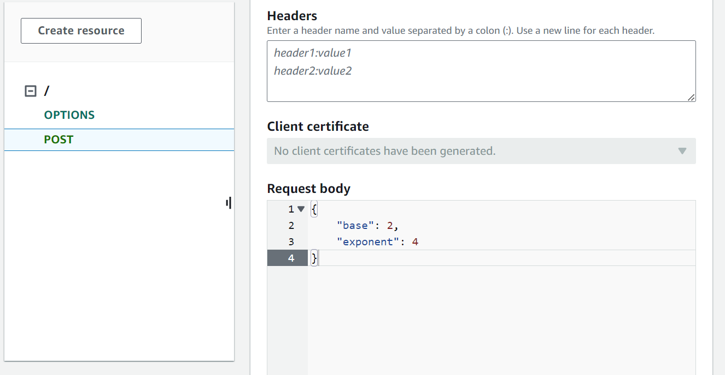
- If the integration is working then you will see the following output
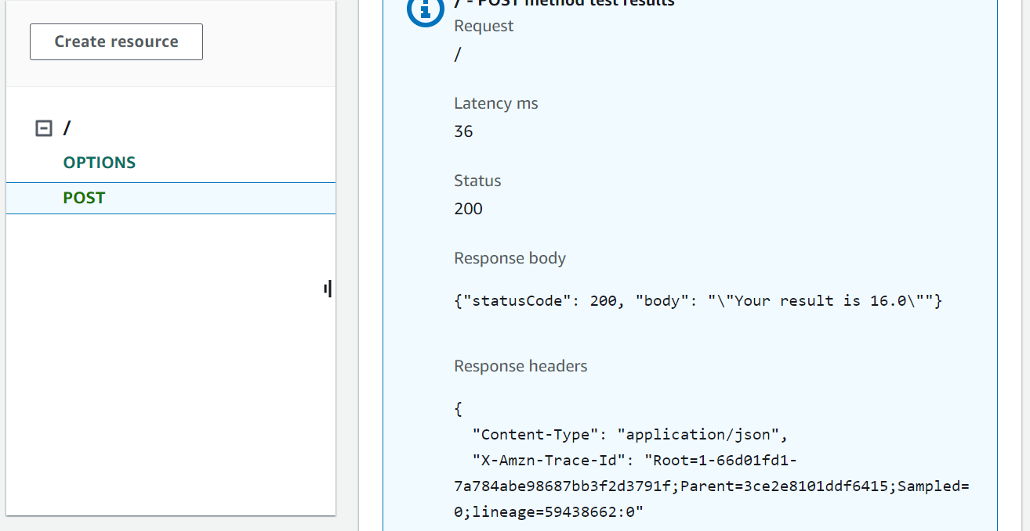
- Now assume that we want to store the result of this calculation in a database. Go to DynamoDB and click on Create table. Name Partition key as ID and keep rest of the things as it is. Copy the ARN name of the database and copy it on a notepad for further use
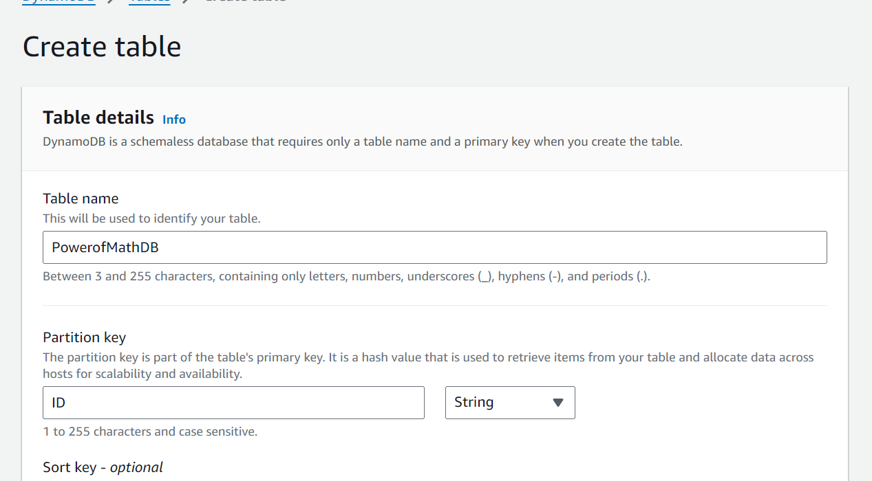
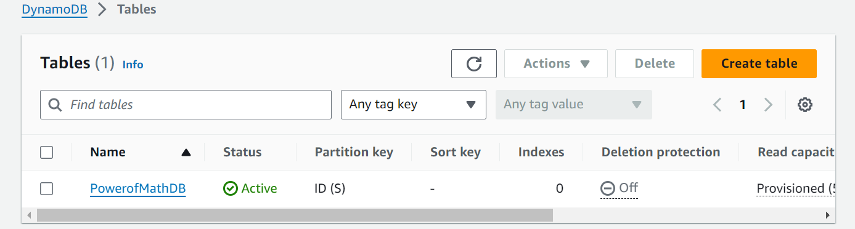

- Now we have to give permissions to the Lambda function to write to the DynamoDB. You can see that API gateway has been added as a trigger for the Lambda function
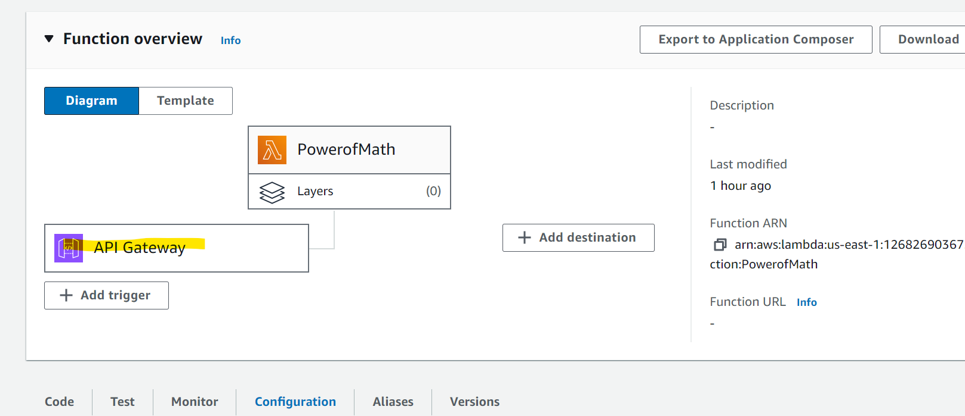

- Go to Configuration and open the role assigned to the Lambda function by clicking on it. You can see that IAM screen opens up
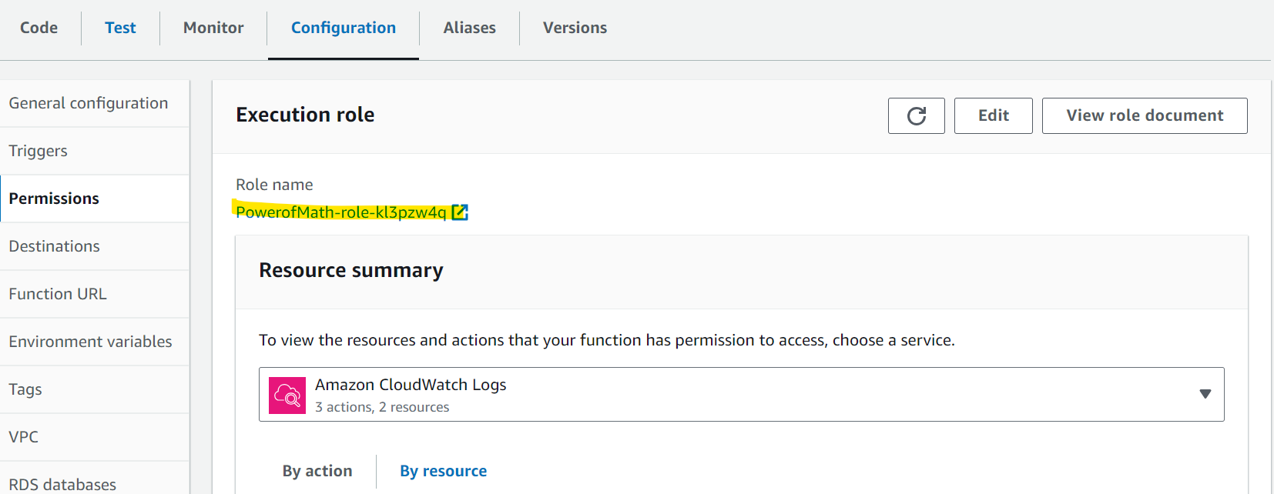
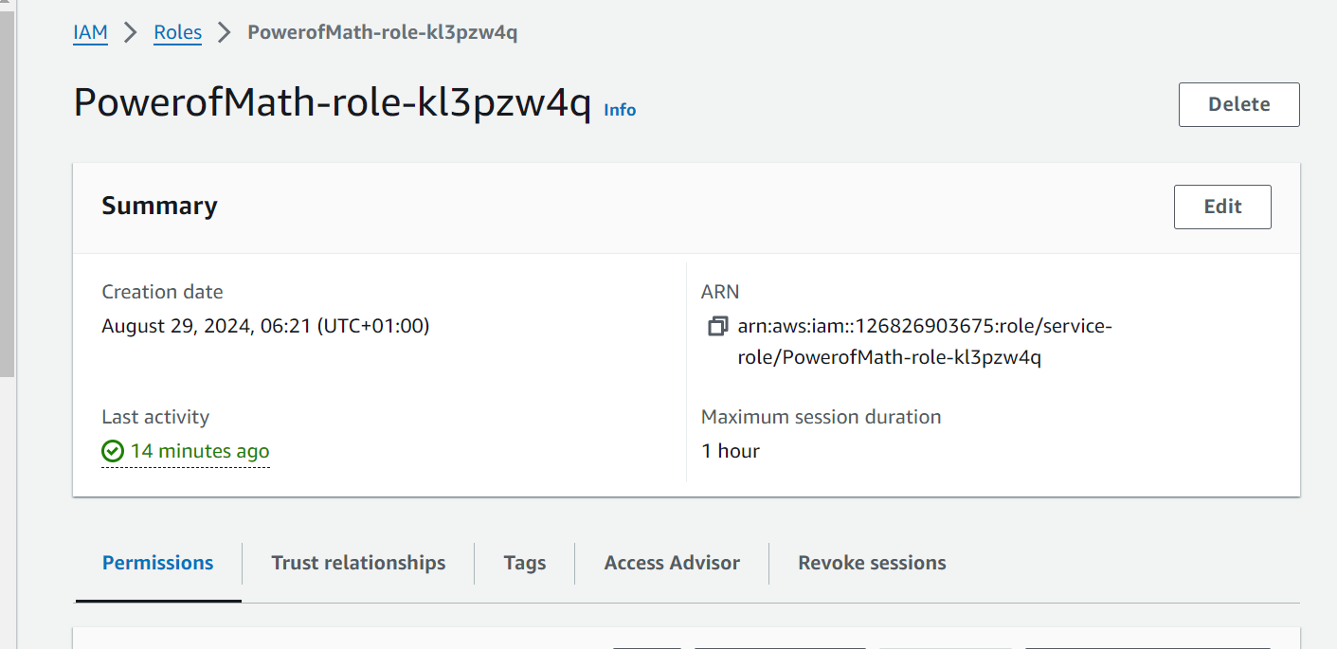

- Go to Permissions and click on Create inline policy. Click on Specify permissions and go JSON view.
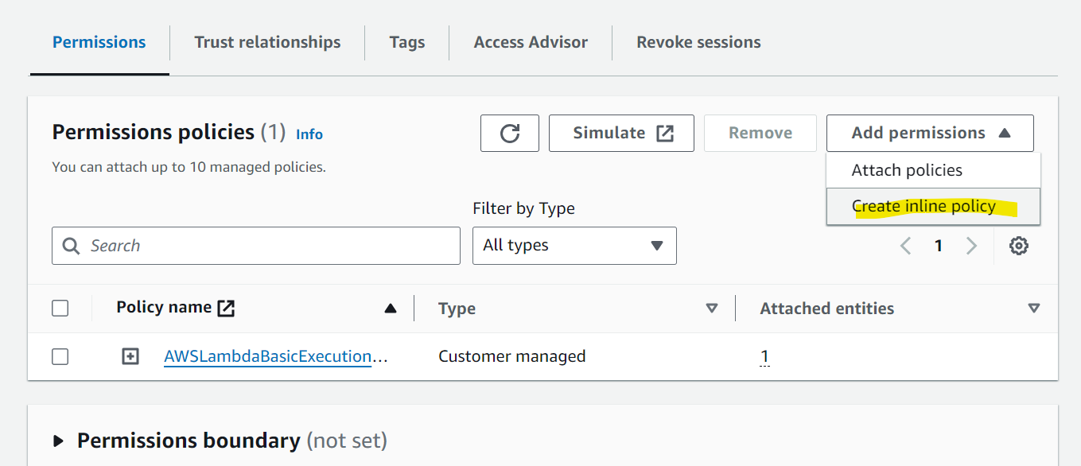
- In the Policy editor section enter following policy and replace the Resource name with your DynamoDB ARN. Click on Next. Give a name to the policy and click on Create
{
"Version": "2012-10-17",
"Statement": [
{
"Sid": "VisualEditor0",
"Effect": "Allow",
"Action": [
"dynamodb:PutItem",
"dynamodb:DeleteItem",
"dynamodb:GetItem",
"dynamodb:Scan",
"dynamodb:Query",
"dynamodb:UpdateItem"
],
"Resource": "ARN of your Dynamo DB"
}
]
}
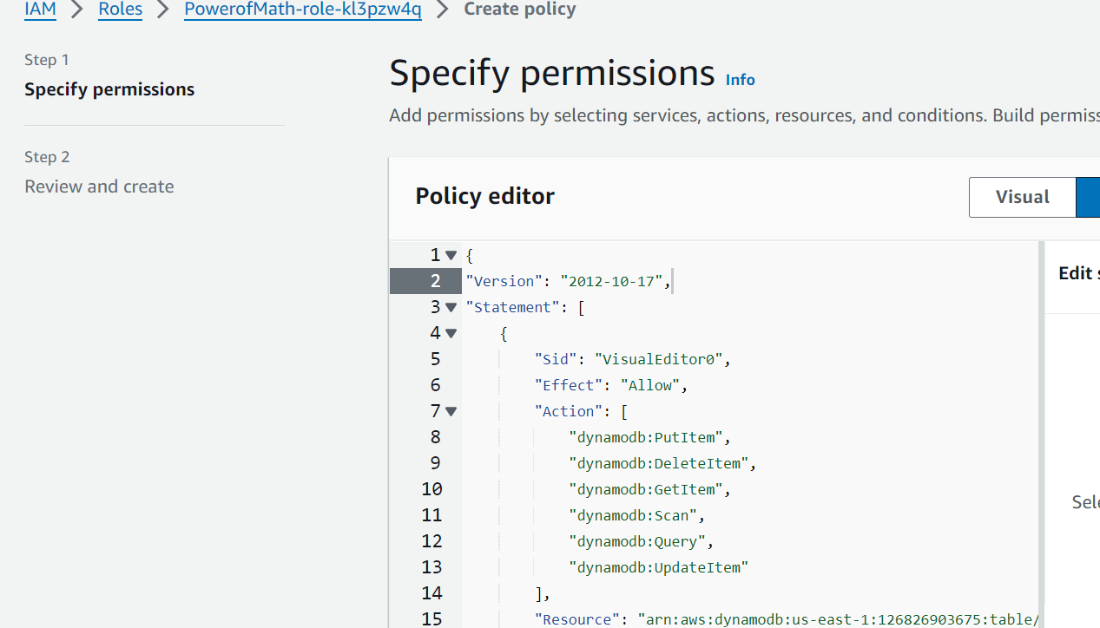
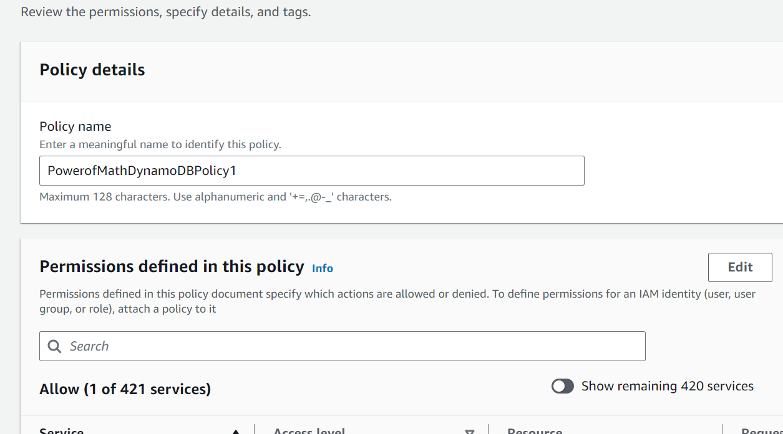
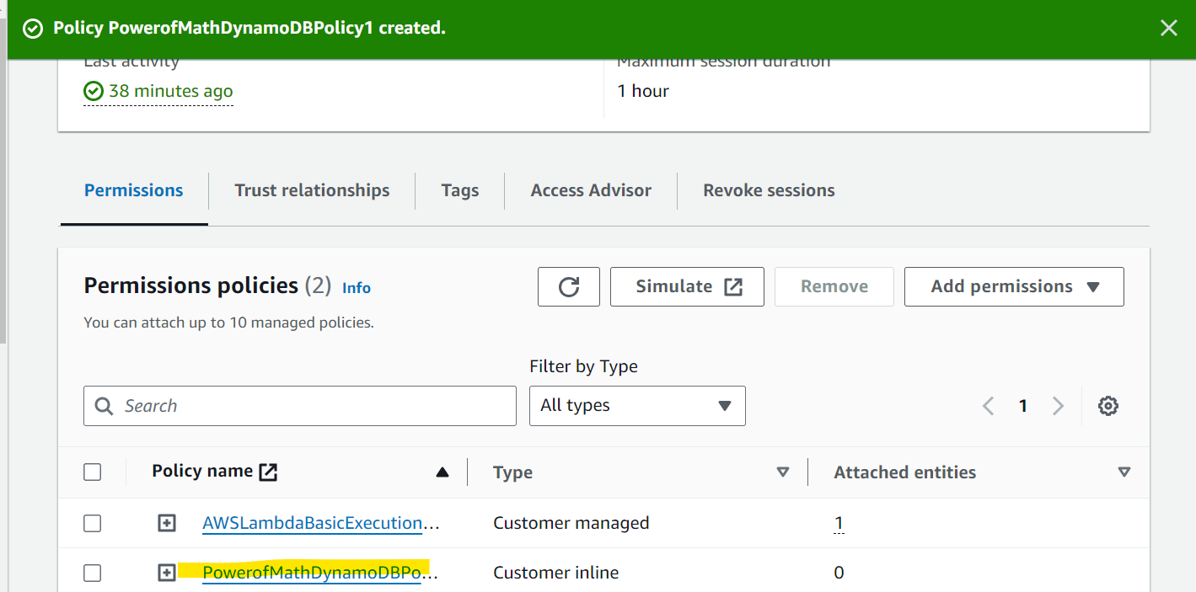

- Now update the Lambda function to update the database. Use following code in the Lambda function. Replace the table name with the Dynamo DB table you have created. This code is using boto3 which AWS SDK. It is used to call AWS services in the python code. In this code we will insert the output of calculation and the current time in the Dynamo DB table. Save and Deploy the code
# import the JSON utility package
import json
# import the Python math library
import math

# import the AWS SDK (for Python the package name is boto3)
import boto3
# import two packages to help us with dates and date formatting
from time import gmtime, strftime

# create a DynamoDB object using the AWS SDK
dynamodb = boto3.resource('dynamodb')
# use the DynamoDB object to select our table
table = dynamodb.Table('DATABASE TABLE NAME')
# store the current time in a human readable format in a variable
now = strftime("%a, %d %b %Y %H:%M:%S +0000", gmtime())

# define the handler function that the Lambda service will use an entry point
def lambda_handler(event, context):

# extract the two numbers from the Lambda service's event object
mathResult = math.pow(int(event['base']), int(event['exponent']))

# write result and time to the DynamoDB table using the object we instantiated and save response in a variable
response = table.put_item(
Item={
'ID': str(mathResult),
'LatestGreetingTime':now
})

# return a properly formatted JSON object
return {
'statusCode': 200,
'body': json.dumps('Your result is ' + str(mathResult)}
- Click on Test and check the output
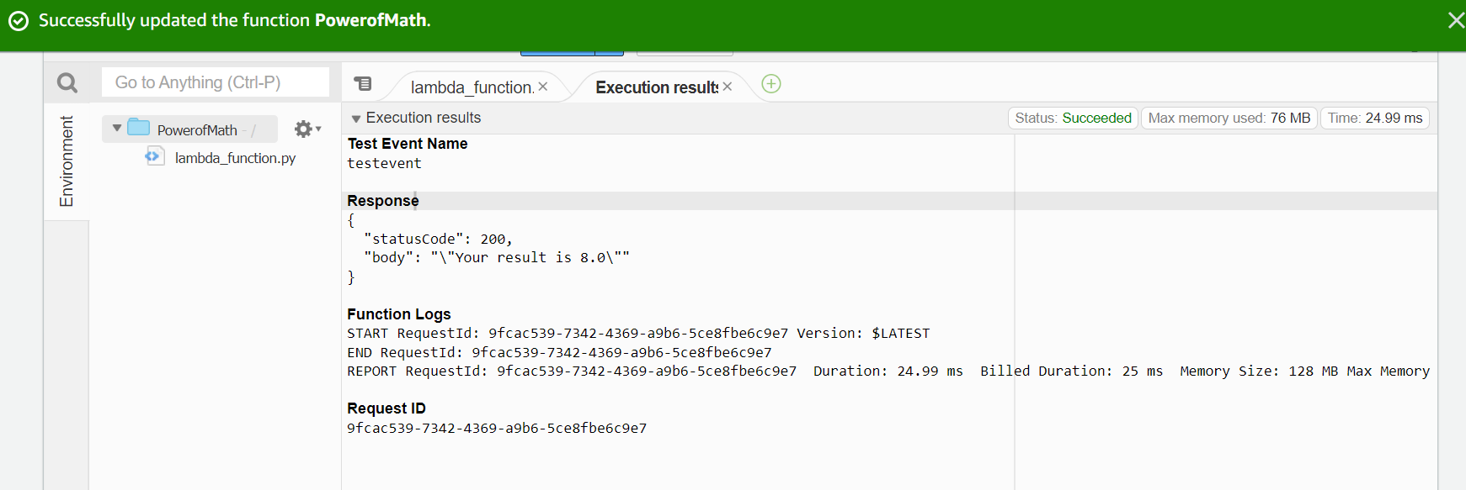
- Go to the DynamoDB table and check items returned. You can see that the output has been stored in the table
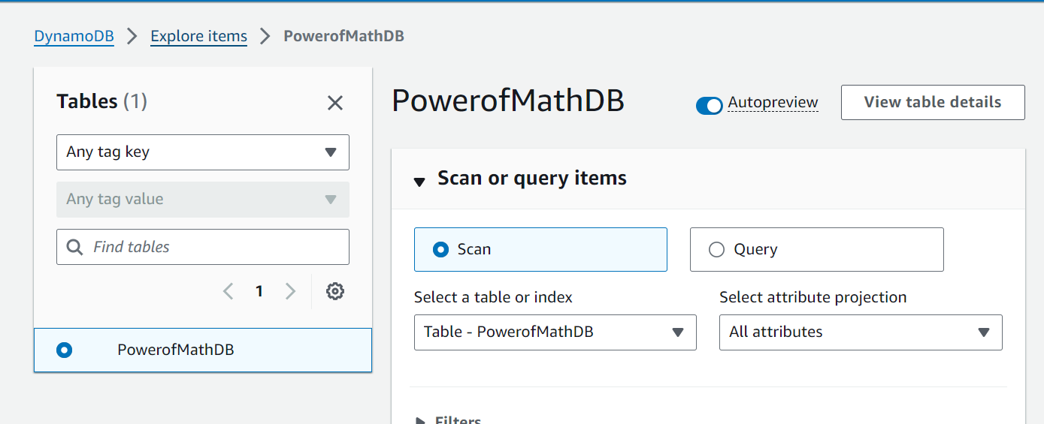
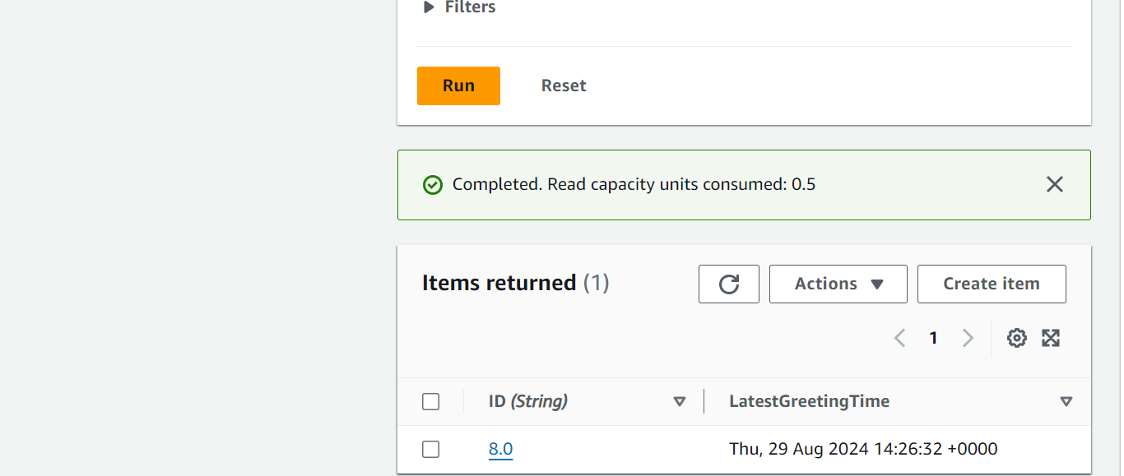

- Now we need to set up connectivity between index.html and API gateway endpoint. For that use the following index.html file with the updated code. Replace “YOUR API GATEWAY ENDPOINT” with the API endpoint link for your API gateway. Zip that file and upload it to Amazon Amplify. Click on Deploy updates. API endpoint can be found in the Lambda function.
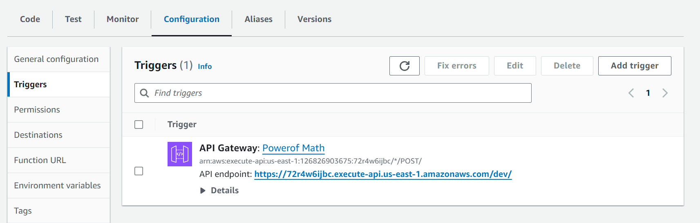

https://github.com/vaibhavchinchmalatpure/projects/blob/main/index.html

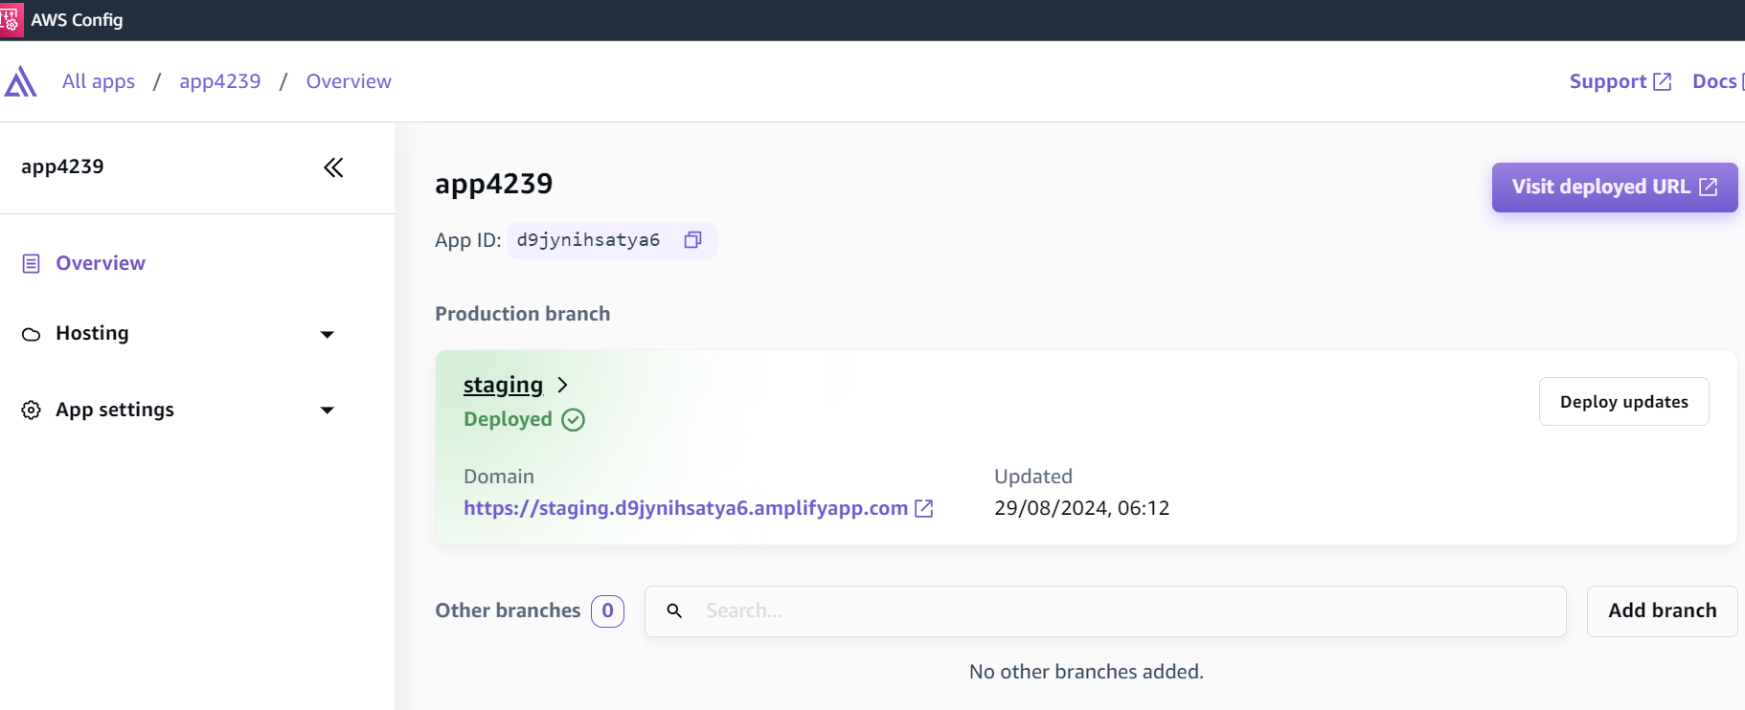
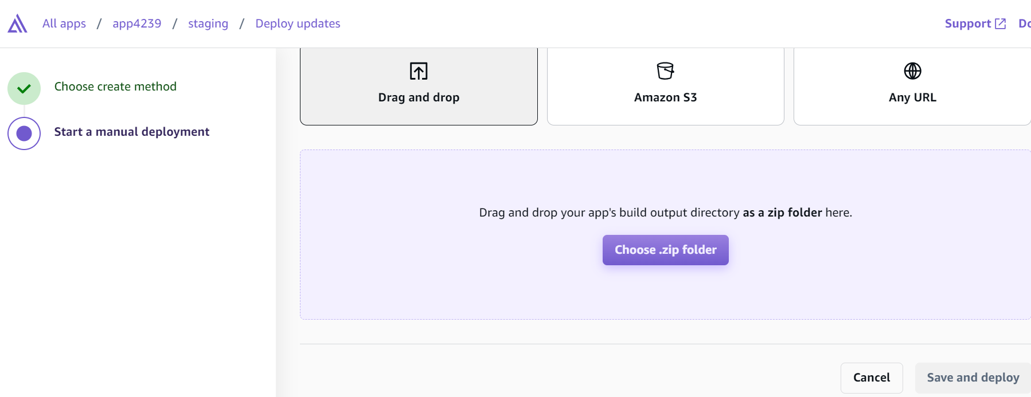
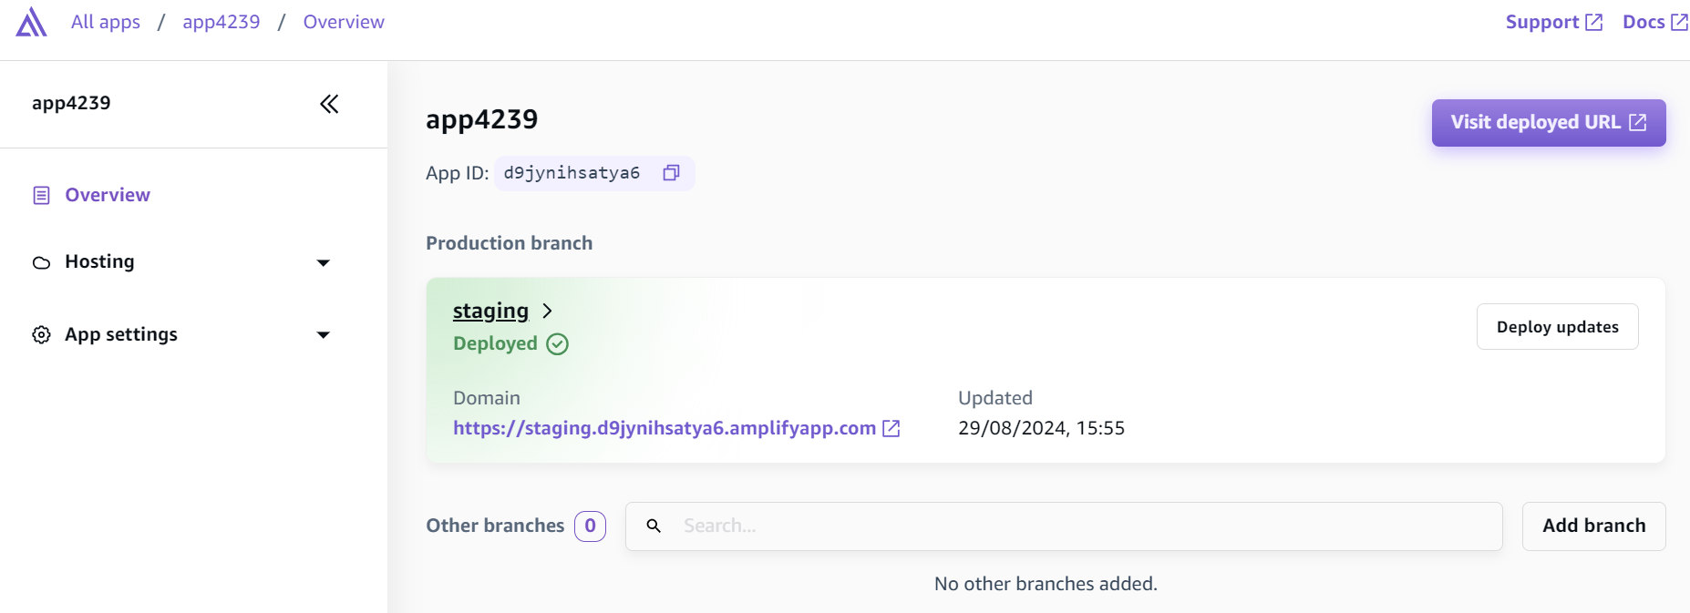

- Open the domain in the above screenshot which is the Amplify link of the Index.html. Enter Base number and the exponent. Click on CALCULATE and you would see the result in the pop up
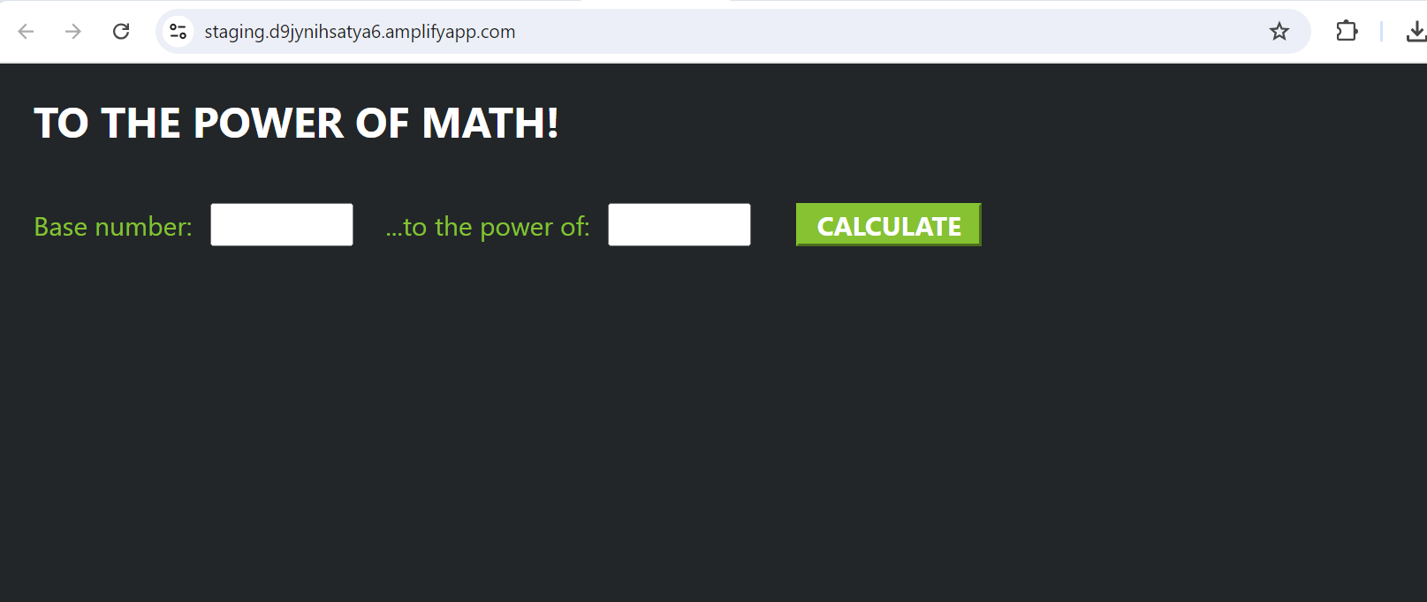
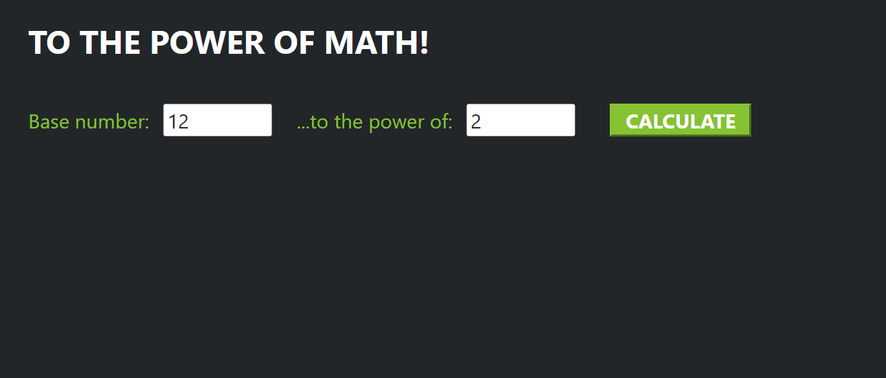
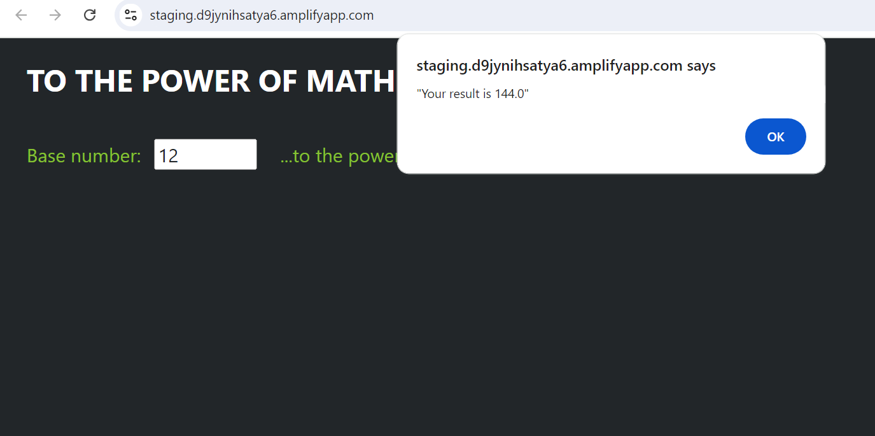

- Go to DynamoDB table and check if the calculation result, i.e. 144 has been inserted in the table or not
